***Rapport***

Regression :

**Neural networks :**

**Definition :** A neural network is a computational system that creates predictions based on existing data. A neural network consists of:

* **Input layers:**  Layers that take inputs based on existing data
* **Hidden layers:**  Layers that use backpropagation to optimise the weights of the input variables in order to improve the predictive power of the model
* **Output layers:** Output of predictions based on the data from the input and hidden layers.

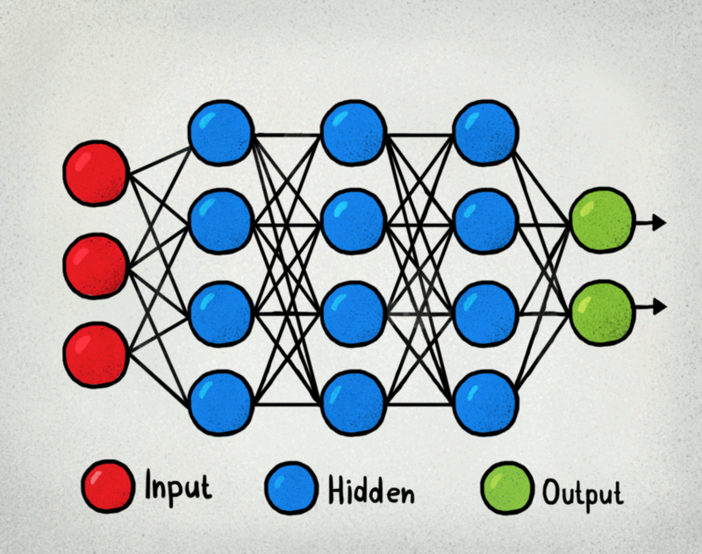

Figure1 : Neural Networks

Application of Neural Networks

For our exemple we use the linear activation function to create a regression-based neural network. We will use the Metro Interstate Traffic Volume dataset . Essentially, we are trying to predict the value of a potential traffic based on the following attributes:

Holiday :Categorical US National holidays plus regional holiday, Minnesota State Fair  
Temp :Numeric Average temp in kelvin  
Rain_1h :Numeric Amount in mm of rain that occurred in the hour  
Snow_1h : Numeric Amount in mm of snow that occurred in the hour  
Clouds_all :Numeric Percentage of cloud cover  
Weather_main : Categorical Short textual description of the current weather  
Date_time : DateTime Hour of the data collected in local CST time  
Traffic_volume : Numeric Hourly I-94 ATR 301 reported westbound traffic volume

**Step to produce Neurale Networks : Using MLPRegression**

## Step 1 : Import the library and Setting up the Data for Regressor :

## We have imported Metro instance traffic volume dataset from the module datasets and stored the data in X and the target in y. We have also used train_test_split to split the dataset into two parts such that 20% of data is in test and 60%in training.

## Step 2 - Using MLP Regressor and calculating the scores :we have used the test data to test the model by predicting the output from the model for test data.Now We are calcutaing other scores for the model using r_2 score and mean_squared_log_error by passing expected and predicted values of target of test set.

## 

## Figure 2 : MLP methode

## Step 3 - Ploting the model :

## 

## Figure 3/ : Ploting the prediction

**Application of Neural Networks using Keras :**

Step 1 : We import the liberary and setting Up the date ,normalized the variable using the **preprocessing.normalize()**

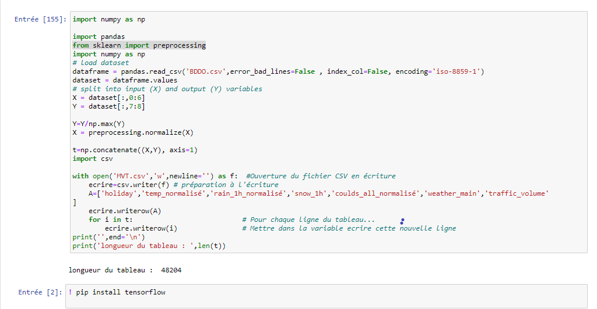

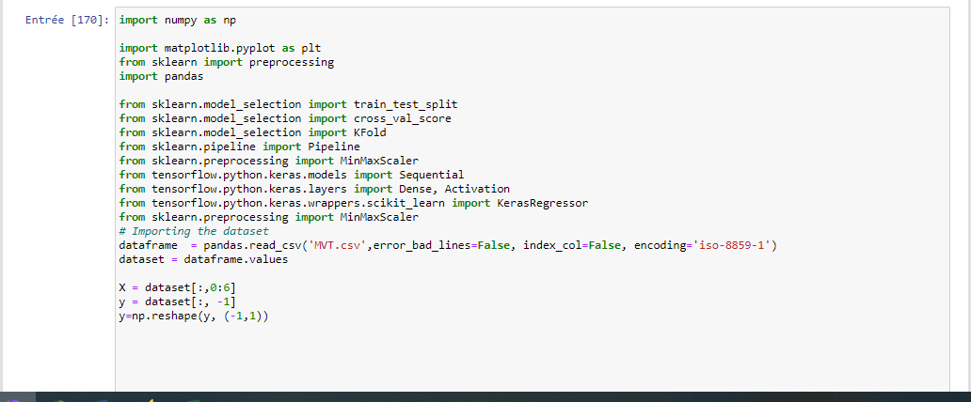

Figure 4 : normalize the data and import it.

Step 2 :The data is then split into training, validation and test data:

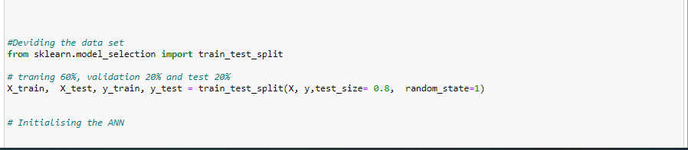

Figure 5 : Splite the date into training and validation and test

Modele Configuration :

What is the meaning of model sequential () ?

The sequential API allows you to create models layer-by-layer for most problems. It is limited in that it does not allow you to create models that share layers or have multiple outputs .

Step 3 : We train the neural network. We are using the six **input variables** ,along with **two hidden layers** of **12** and **8** neurons respectively, and finally using the **linear activation function** to process the output.

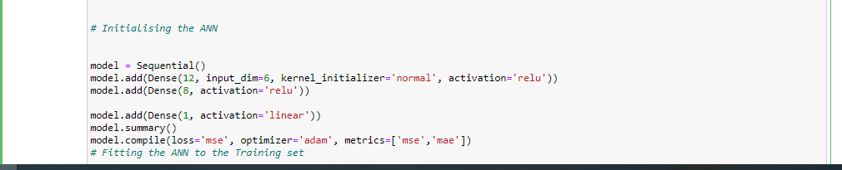

Figure 6 : Sequential modele

The **mean_squared_error (mse)** and **mean_absolute_error (mae)** are our loss functions – i.e. an estimate of how accurate the neural network is in predicting the test data. We can see that with the validation_split set to 0.2, 60% of the training data is used to test the model, while the remaining 20% is used for testing purposes.

Step 4 :Now fit our model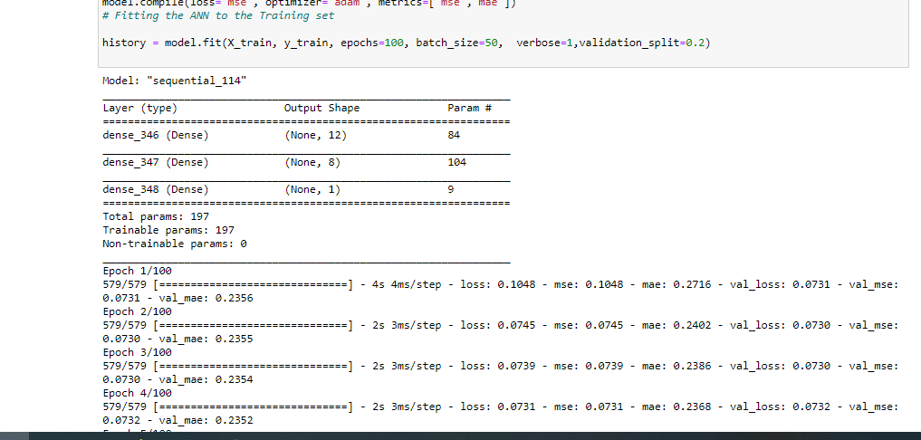

Figure 7 : Fiting the modele

Here, we can see that keras is calculating both the **training loss** and **validation loss**, i.e. the deviation between the predicted y and actual y as measured by the mean squared error.

plot our respective losses

Step 5 :Ploting the Model

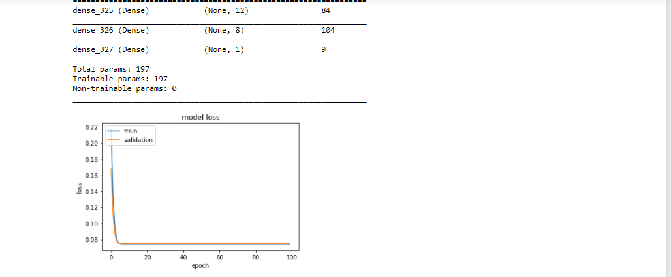

Figure8 : ploting the validation and the train Loss

Both the training and validation loss decrease in an exponential fashion as the number of epochs is increased.

**Note**: I used two different method to calculate the variation between prediction and excepted (ytest) but I can't got the right result ( variance secore =0.03)